Packed Circle Chart

Connect to Superstore data source and cross join with the model data source

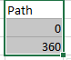

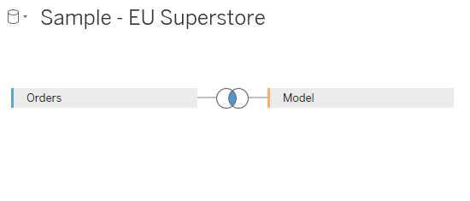

Drag Segment to the color shelf and create bin for the path.

Create the following calculated fields.

Index

INDEX()-1

X

SIN(RADIANS([Index]))

Y

COS(RADIANS([Index]))

Drag X and Y to the columns and rows shelf respectively.

Change the marks to polygon and drag the path(bin) to the path shelf.

Check compute using path(bin) for the X and Y in the columns and rows shelf respectively.

Create the following calculated fields.

TC_Sales

WINDOW_SUM(SUM([Sales]))/2

Edit the calculated fields X and Y as follows

SIN(RADIANS([Index]))*[TC_Sales]

COS(RADIANS([Index]))*[TC_Sales]

And compute using path(bin)

Click on the colors tab on the right hand side and sort as follows.

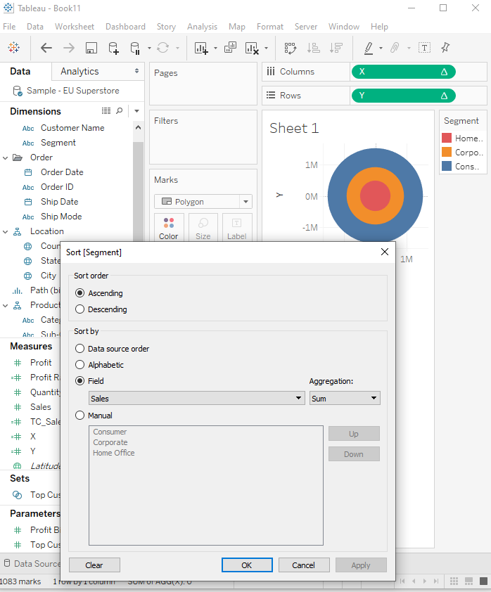

Edit the calculated field Y as follows

(COS(RADIANS([Index]))*[TC_Sales])+[TC_Sales] and the output looks like below.

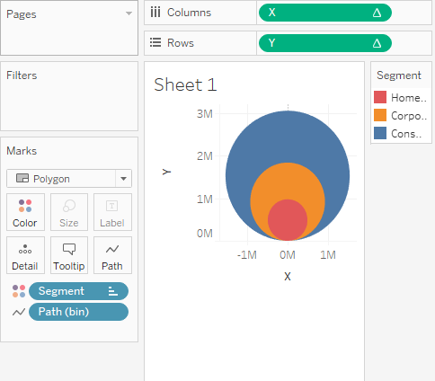

Control click the Y on the columns shelf and duplicate it and change the marks to line.he

Click on the first Y and change the color opacity to 30%.

Click on dual axis on the second Y and synchronize the axis and remove the headers and the grid lines.

Drag TC_Sales to the tool tip and format as desired.